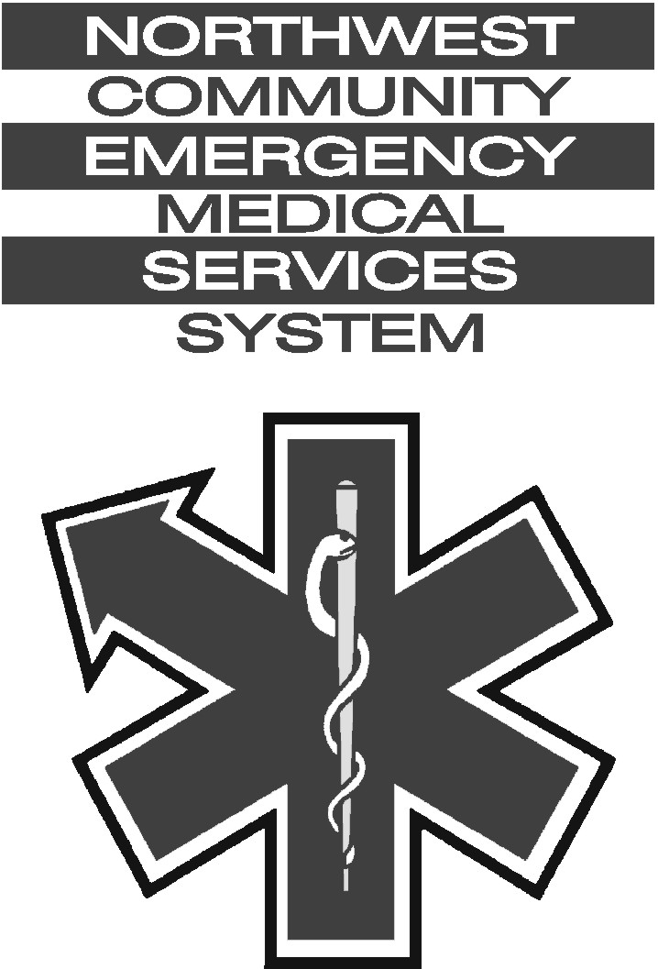

Northwest Community EMS System

Date: May 12, 2011 System Memo: # 329
To: Chiefs, administrators
NWC EMSS Provider EMS Coordinators/Hospital EMS Coordinators
From: CARS Committee
RE: Go live date for Field Bridge Software - June 1, 2011
FINAL CHECKLIST

With the June 1st Field Bridge implementation deadline quickly approaching, the CARS committee is working to finalize the System-approved template and would like to remind all agencies of some work that needs to be done on their end to make sure that everyone is prepared for the transition. The following items should be completed as soon as possible if they have not already been done:

- Verify that all tablet PCs are functional and current with Windows updates and Adobe Reader.
- Complete the Field Bridge setup for your agency within Service Bridge (Service Setup -> I want to…-> Manage Field Bridge Options).
- Install the Field Bridge software (based on the license(s) purchased by your agency) and any updates to all tablet PCs.
- Configure each tablet PC for Field Bridge use.
- Sync each Field Bridge tablet to get up-to-date personnel rosters and report templates. Under the Staff tab, Agencies must check the box under everyone's permission to sync to Field Bridge.
- Configure Wi-Fi settings for each site where internet connectivity for run posting is needed (provider stations and/or hospitals) and verify connectivity.
- Install printer drivers for the printers at every hospital your agency transports to and visit each hospital to confirm that the tablet(s) can, in fact, print a PCR.
- Verify that a fully valid report can be completed using the NWCEMSS - DO NOT MODIFY template on each tablet PC. Report any errors encountered to Adam Rothenberg or Rick Nosek of the CARS Committee.
- Designate at least one “Super User” for your agency. This should be someone who attended the training in December 2010 and will be the first point of contact for your agency’s field personnel should they encounter any problems with the Field Bridge software. This person should be available 24/7 during the rollout, so it may be advisable to have one “Super User” per shift.

Taking care of these infrastructure items ahead of time will greatly increase the likelihood of a smooth and successful rollout of the Field Bridge product. Please report back to Connie Mattera when these items have been completed.

If you have any questions related to setup of Field Bridge tablets, please contact Rick Nosek or Adam Rothenberg of the CARS committee.

Please also make sure that your agency’s users have completed the practice/fictitious report entries using the NWCEMSS-DO NOT MODIFY template. The final NWCEMSS template should be completed and approved within the next week and will be pushed out to all Field Bridge tablets as soon as it is available.

