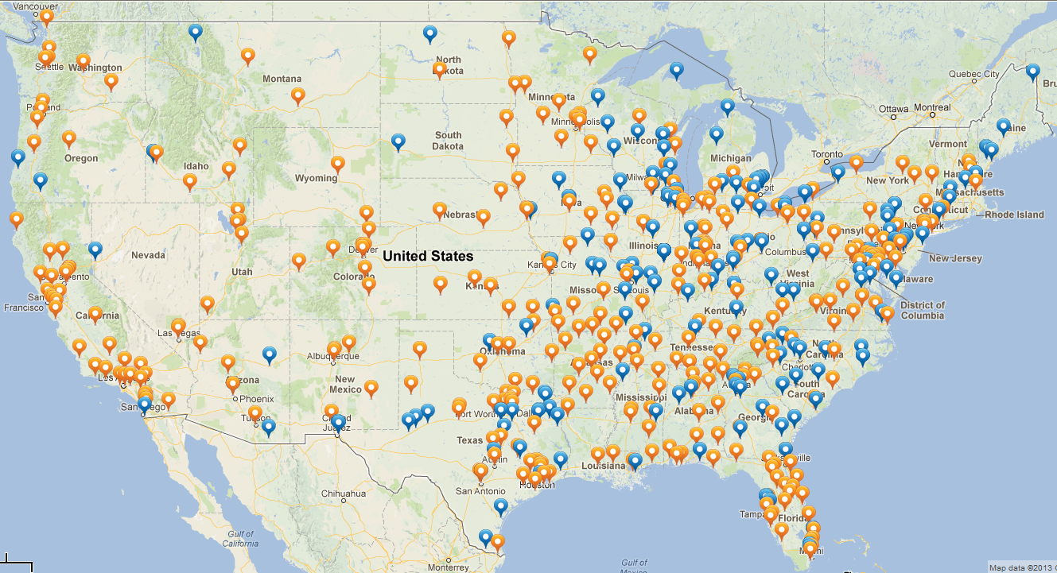
As of January 17, 2013, there are almost 600 programs in the CoAEMSP/CAAHEP system
CAAHEP Accredited Paramedic Programs = 330
CoAEMSP Letter of Review Programs = 205
Another 52 are On Hold, and 10 more

